<Insert Company Logo>

Business Resiliency Plan
<Insert Company Name> Updated: <Date>

Person Responsible for Business Resiliency Plan at Firm:
Additional Resources (Consultants):

Introduction
This Business Resiliency Plan is meant to work with Business Resiliency Guide in order for you to create a plan that will help you respond to most emergency situations and recover as quickly as possible. If more space is needed on any of the tables provided in this worksheet, they are provided on a single page, so that you can print out more copies.
You will start by identifying your critical business functions and their supporting resources. You will then identify risks your business could face. You will then look into how these risks could affect your critical business functions and resources. With this information you can create your business continuity plan (includes the communications plan from the Business Resiliency Guide). Then you will fill in the preventative measures you can take to mitigate risk from your most likely hazards.
In the identify section of the Business Resource Guide you identified the hazards your business is most exposed to and their severity. The last section of this business resiliency plan provides a template for you to take those hazards and develop emergency response plans. These plans encompass both preparation for hazards and the appropriate actions to take in reaction. The MSBDC website has resources you can use to help develop your emergency response plans.
This template was compiled by the Washington State University – Small Business Development Centers Market Intelligence Research Program.

Critical Business Functions and Resources:

These are our critical business functions and the resources they need. Without these our company cannot continue to operate.

Critical Business  Function | Supporting Resource(s) | Function Of  Resource | Backup Resource(s)

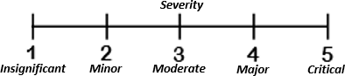
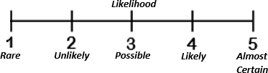
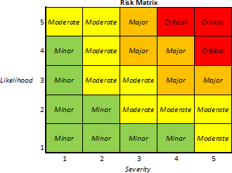
Hazards
Our business is exposed to the following hazards. These could affect our critical business functions, preventing us from continuing business.

HAZARD | How Likely? (1-5) | How Severe? (1-5) | Risk | NOTES

Business Impact Analysis
If one of the above threats takes place these will be the likely business functions and resources affected. If one of these resources or functions is lost, we should work quickly to replace it.

Disaster | Business Functions Impacted | Resources Impacted | Recovery Time Objective | Operational Impacts | Financial Impacts

Business Continuity Plan
This is our plan of action following a disaster. By following this we will be able to keep our business in operation or return to operation as quickly as possible.

These are the critical business functions we need run our business:

Critical Function | Recovery Time  Objective | Staff in  Charge | Resources Needed | Backup Resources

This is our backup location we will use if our primary offices are compromised:

Backup Location:
Address:
Phone number:
Person Responsible for Contacting: Name:
Contact Info:

Map with backup location marked

Emergency Communications Plan
Name | Role |  | Phone & Address
Methods of communication (Cell phone, social media, person-to-person)
Method | Person  Responsible |  | Notes

Our backup Suppliers and Distributors are

Backup Suppliers:
Company Name: Address:
Phone: | Fax: | E-mail:
Contact Name: |  | Account Number:
Materials/Service Provided:
Backup Distributors: Company Name: Address:
Phone: | Fax: | E-mail:
Contact Name: |  | Account Number
Materials/Service Provided:
How to Use:

Preventative Measures
What are some proactive preventative measures your business could take to mitigate risk?

Hazard | Preventative Measures

Emergency Response Plans
<Insert Emergency> Emergency Response Plan

<Insert Company Name>
Last Updated: Next update: Person Responsible For This Plan:

Preparation:

Action:
Person Responsible:

